1. check if the given number is positive or negative. Code:

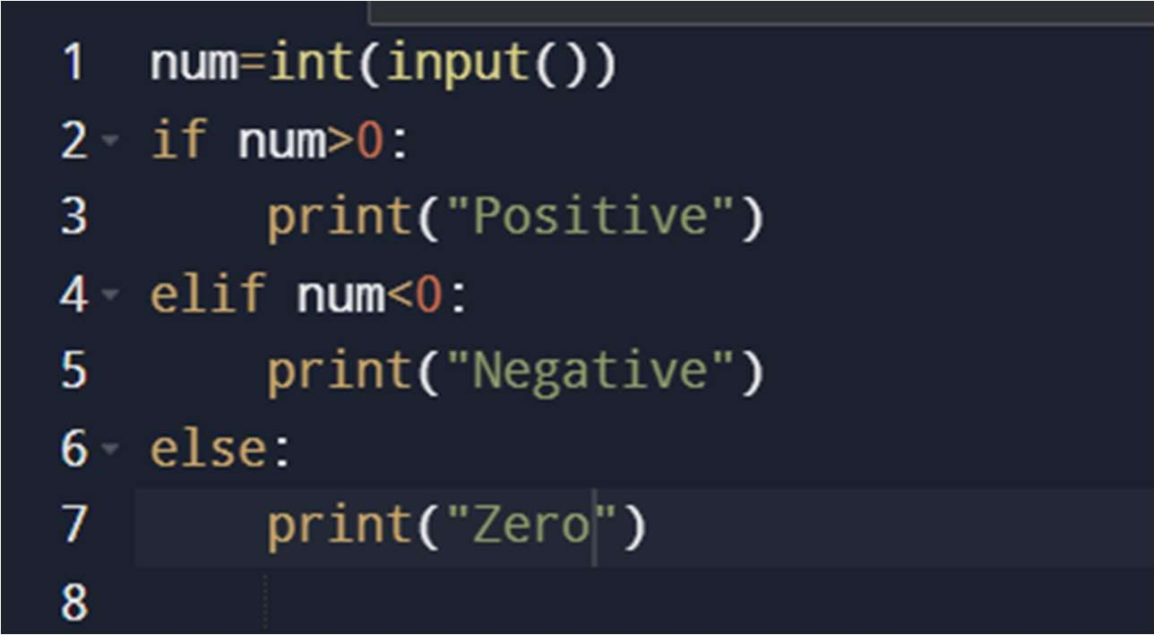

Sample i/p and o/p:

Test1:

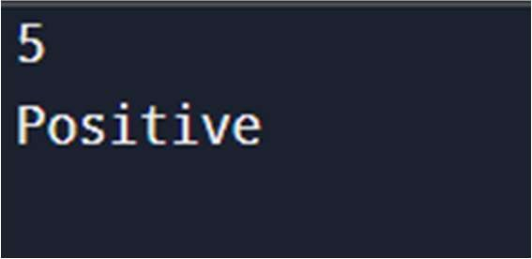

Test2:

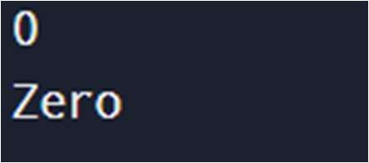

Test3:

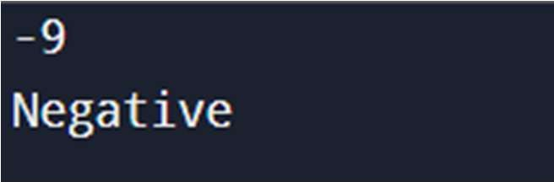

1. Check if the given number is even or not. Code:



Sample i/p and o/p: Test1:

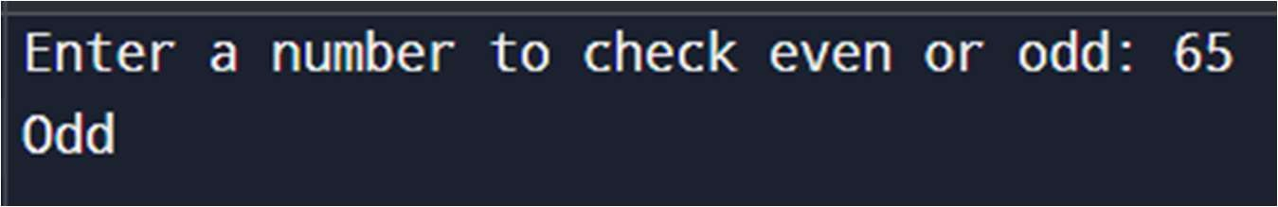

Test2:

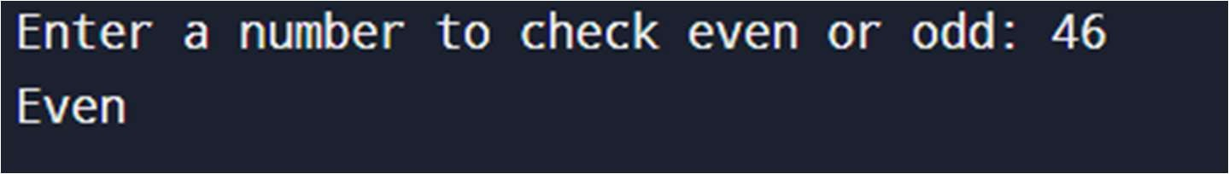

1. sum of natural numbers. Code:

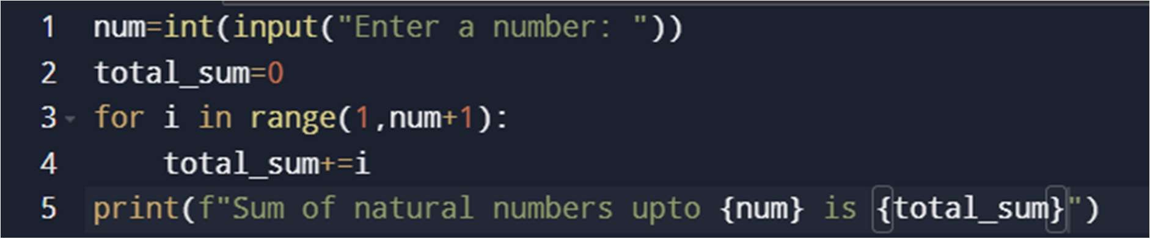

Sample test:

